Hall’s Independent Research on The Science of Reading
Findings & Implementation for Best Literacy Instructional Practices
To be followed up after five to seven years to determine the overall effects of the implementation of CKLA/Amplify or other proclaimed structured literacy programs.
Action Research Study Conducted and Recorded By:
Maggie K. Hall, BBA, M.Ed., ILS

“Prevention is better than Intervention. To prevent reading failure, educators must understand and act on scientific evidence. Humans invented reading and now have to teach these skills to every new generation.”

Preface: The Obstacles with Past Balanced Literacy Programs
Emily Hanford of AMP Reports states, “What’s happened in the name of balanced literacy is what you find in a lot of classrooms that are doing a little bit of everything all at once. And what the research shows is that’s not actually what kids need. What you really want to see in early reading instruction, when kids are first coming to school—and remember, the task ahead of them is not to learn a whole bunch of words, they already have this advantage, they speak a language. Now they have to learn the written code.”

Emily Hanford of AMP Reports also states, “I think what happens in a balanced literacy classroom is there’s potentially a lot of time lost, like a lot of stuff sort of left on the table because there’s not enough time being devoted to the phonics and phonemic awareness, the alphabetic principle, the written code. And it’s also important to understand what we mean by explicit and systematic because what’s happening in a lot of classrooms is that phonics is being taught kind of incidentally like it comes up as kids struggle with words. There’s a particular letter pattern that they’re struggling with, so the teacher will teach a mini-lesson on that, and a lot of stuff kind of gets lost because you don’t necessarily know all ... unless you’re listening to every single kid read everything out loud, you’re not going to know all the different patterns that kids are struggling with.”

So… Why Change Now?
Hundreds of Scientists all over the world have conducted thousands of studies about how the human brain learns how to read over the past few decades now. Here is a diagram representing the findings beginning from 1986 to current:
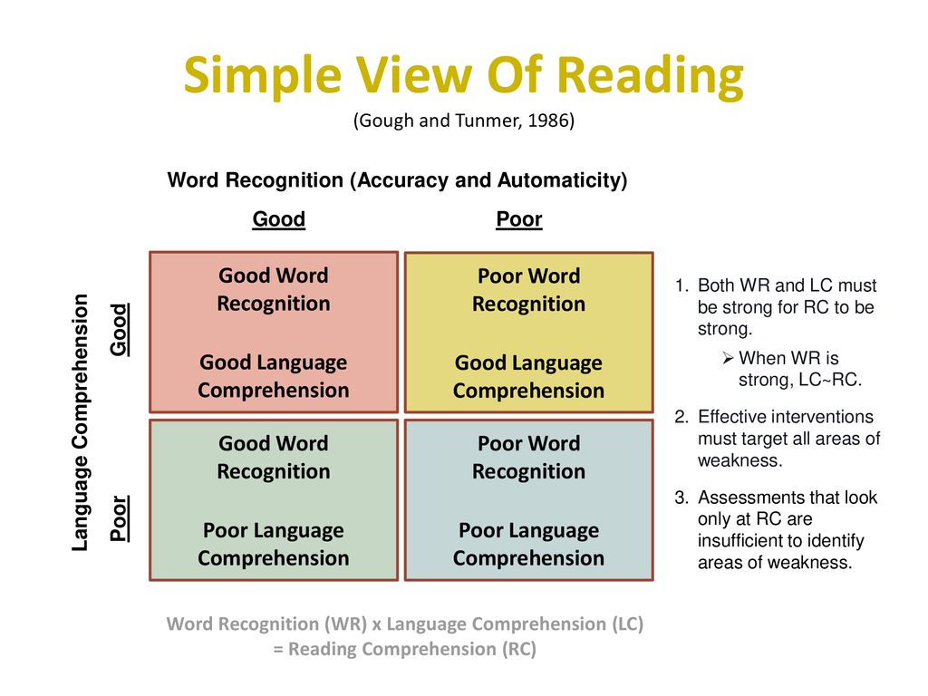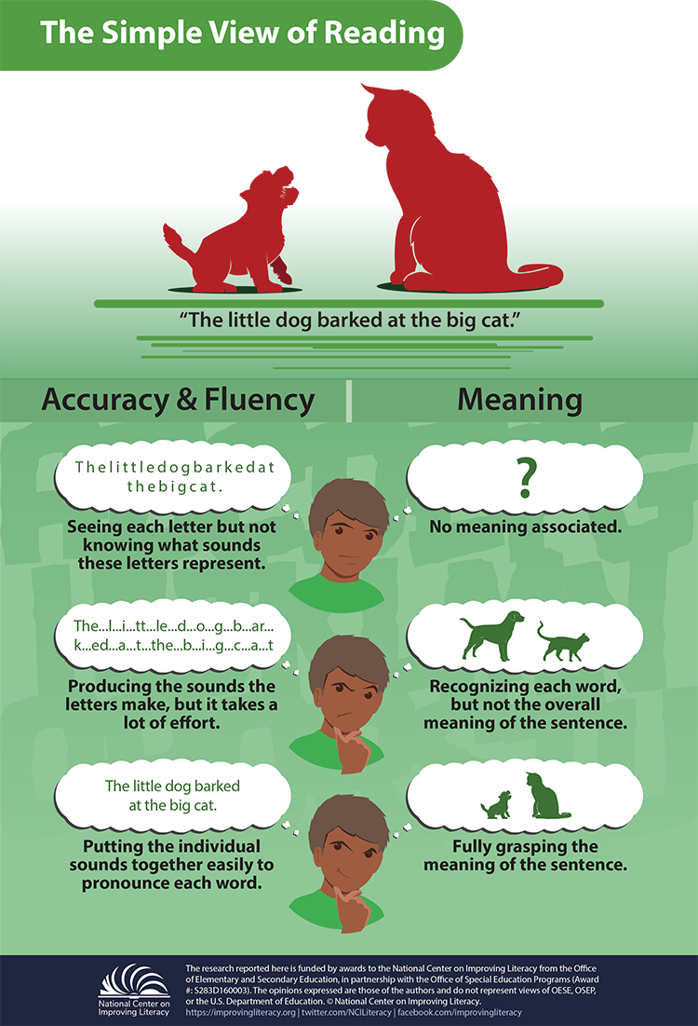

Now we Know:
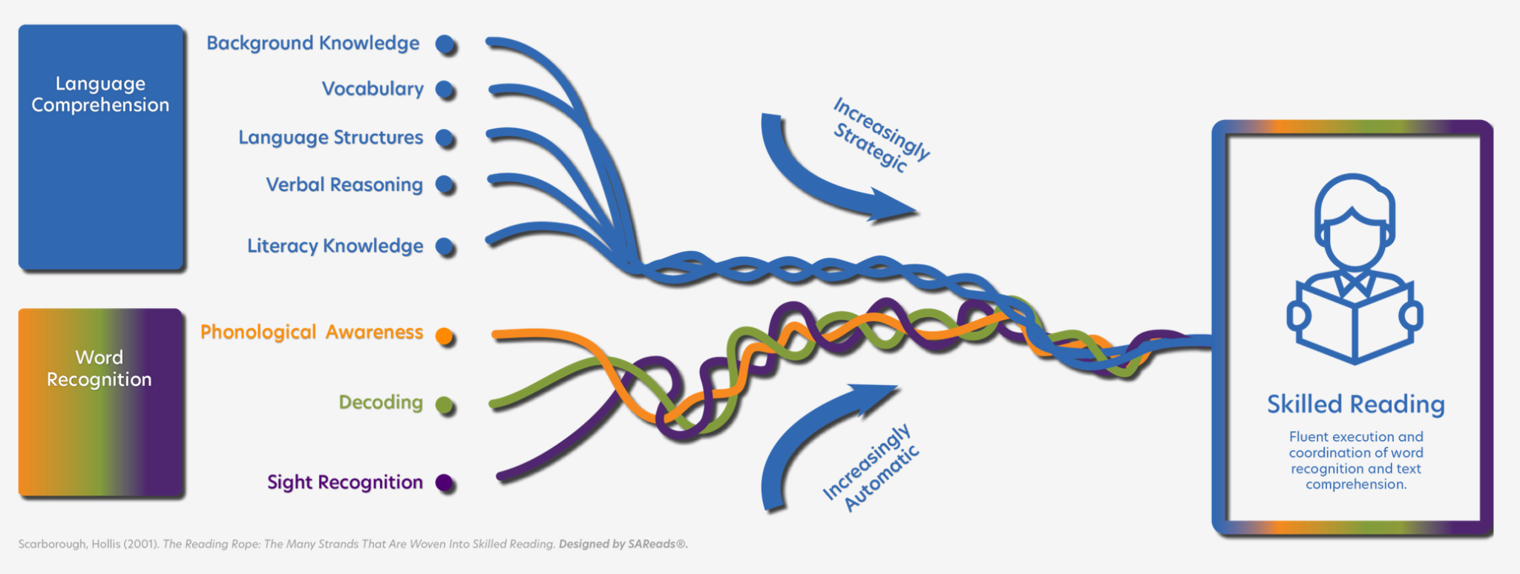
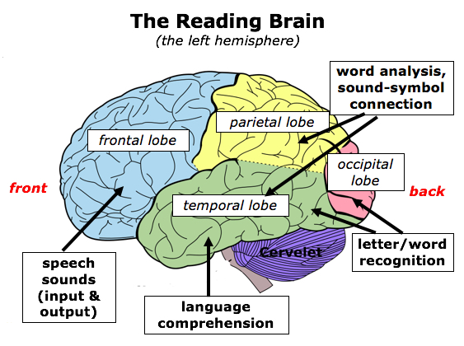

There’s a lot that we all need to understand about how the English language works to be able to teach it well to children. Currently, we seem to have this wide gap between research and practice, along with the research itself and the knowledge of the English language. Teachers want to be able to effectively teach their kids how to read, therefore we need to self-educate and come together to promote change in our outdated literacy practices that have not shown to be effective or as impactful. School district leaders should advocate for professional training about the science of reading concepts as well as how to best implement a structured literacy program with fidelity.

Literacy Myths-BUSTED:
- Reading is not a skill that is naturally developed like oral speech might be. It has now been discovered that everyone learns how to read in the same way via phonics and phonemic understanding and manipulation.
- Words are not learned as a whole or along with a picture by sight. There are neurons in our brains that help us identify visuals, but not the sound associations that make up our meaning of words. These are things that must be explicitly taught to any student learning how to read.
- Sight word memorization is not effective in early literacy instruction.
- Pre-School should not be all about PLAY as there is room for direct instruction early on and can be fun if implemented in the right way.
- Reading is NOT a natural capacity that will develop on its own. Reading aloud is NOT ENOUGH. Our brains are NOT naturally wired to read based on Neuroscience studies conducted.

The Latest Findings
There is a scientific and systematic method in which reading skills have been found to be acquired and developed. The Science of Reading begins and is based on emergent reading and early literacy-related foundational skills. Many concepts grounded in the Science of Reading started with research-based in research and support for Dyslexia reading learners.
In the beginning- Words get stored in your brain through processing a word several times through its phonology and through its orthography. So, the way letters and words sound and the way it’s spelled. Research suggests that explicit and systematic literacy instruction is what works best for all students.

The most effective decoding (word reading) instruction is a structured and explicit phonics-based approach. This approach is beneficial to ALL students, not just those with dyslexia or reading difficulties. The National Reading Panel (NRP) Report in 2000 identified instruction in the following five elements as the most important skills students need to become proficient readers.

1. Phonemic Awareness
Phonemic awareness is recognizing that words are composed of individual sounds that can be blended for reading and pulled apart or segmented for spelling.

Phonemic awareness is a crucial skill for all students learning to read and there is a greater emphasis on phonemic awareness in kindergarten and first grade.

2. Phonics
Phonics is a method of teaching students how to connect the graphemes (letters) with the phonemes (sounds) and how to use this letter/sound relationship to read and spell words. Phonics is a key component to reading because decoding is the foundation upon which all reading instruction is built.

3. Fluency
Reading fluency is reading text with sufficient speed and accuracy to support comprehension. The practice of developing fluency in children includes reading accuracy, reading rate, and reading expression. Instruction in reading fluency should include assisting students in developing their ability to use typical speech patterns and appropriate intonation while reading aloud.

4. Vocabulary
Vocabulary is the understanding of individual word meanings in a text. Teachers should develop students’ vocabulary knowledge through direct and indirect methods of teaching and students should be exposed to vocabulary both orally and through reading.

5. Comprehension
Comprehension is the understanding of the connected text and is the goal of reading.

Other key takeaways (in no particular order) include but are not limited to:

- Explicit phonics instruction is just one non-negotiable component of the many complex fibers that make up developing reading fluency and comprehension skills. There is no reason that teaching phonics cannot be fun and interesting for the teacher and the students.

- Practicing or rehearsing fluency is equally as important as direct or explicit phonics instruction. Fluency is built up through the intentional practice of short words and phrases, especially prepositional terms using sight words or common words seen throughout various texts.

- Children also need background and vocabulary knowledge so that they comprehend what they are reading. Eventually, children need to recognize words automatically and read text fluently while at the same time attending to grammar, sentence structure, and punctuation. Decades of scientific research have shown that reading does not come naturally. The human brain is not wired to read.

- Readers’ theater and poetry are great ways to begin this practice in fluency stamina. Speeches from the past that became famous or even printed musical lyrics and songs are other good options for practicing reading expression which also ties back into reading fluency.

- Dyslexia students have an issue with identifying the final logical components of a word or sound, not so much that they see things backward. For example, a student that sees the letters ‘ee’ may internally interpret them to sound like ‘a’ which makes reading development more complicated.

- When observing a struggling reader, try using nonsense words to determine if students can decode or make sense of them and if not, you need to backtrack to Vining and sound and phonological awareness before moving forward in the reading development process.

- In addition to fluency, students need to practice reading comprehension, which is very helpful, to begin with building up students’ background knowledge on a certain topic subject or thematic unit. Background knowledge deserves time and focuses for students.

- Note to self: One thing that I’m noticing and is thematic and everything that I am learning about the science of reading is that regardless of a learner‘s age if you have to go back to the very beginning basics then that’s what you have to do and they can build upon that even as an upper-grade student and get caught up quickly. So even in kindergarten and pre-K instead of just beginning with memorizing letters and trying to pry those letters to words and sounds, they begin with breaking down phonemes final logical awareness starts submitting words clapping along with syllables rehearsing words sounds rhyming words tricky words short phrases, and just really laying down pre-requisite skills required to build upon for science of reading comprehension over time.

- Random Idea: School leaders could host mini-training for teachers that cover CKLA topics so that all CKLA instructors are experts, can bring up ideas and model thinking about the content, and get students excited about their learning.

- The writing component to reading and CKLA must be implemented regularly/daily along with practicing all other skills mentioned to have the most effective impact on literacy development through the structured Science of Reading model.

- Reading comprehension is not a final product but an ongoing mental process for the reader across levels in real-time during word, sound, and phonemic awareness on to —> If readers do not understand the meaning of the most basic and simple words (pronouns, prepositions, sight words) then the learning reader will struggle with making connections to the rest of the texts. For example, the word ‘because’ has the relationship to mean cause and effect. It is important for the teacher to model thinking to help initiate student thinking about the various meanings of simple words from the beginning of literacy instruction.

- ‘Micro-Skills’ require more attention for improved reading comprehension skills. The goal is automaticity. Students store words in their minds for when they come across them again as a reader. Micro-Skills include phonological awareness, orthographic knowledge, and decoding-- are the building blocks of reading (Ehri, 2005). Oral language is a fundamental part of the brain’s reading and learning network which truly needs to become the first foundational layer of learning.

- Students need to be reading and writing across content areas as it relates to those contents to help derive a more deepened meaning of texts as they identify text features. For example, most Science books are going to have graphs, mathematical expressions, graphics, etc. and teachers should work with students to work among these texts to help them develop into better readers.

- Getting parents involved at home in the lower grades in the student’s literacy development is best to implement EARLY intervention which is the best-case scenario.

A Visual for Understanding The (Why What, and How) Concepts behind the Science of Reading:

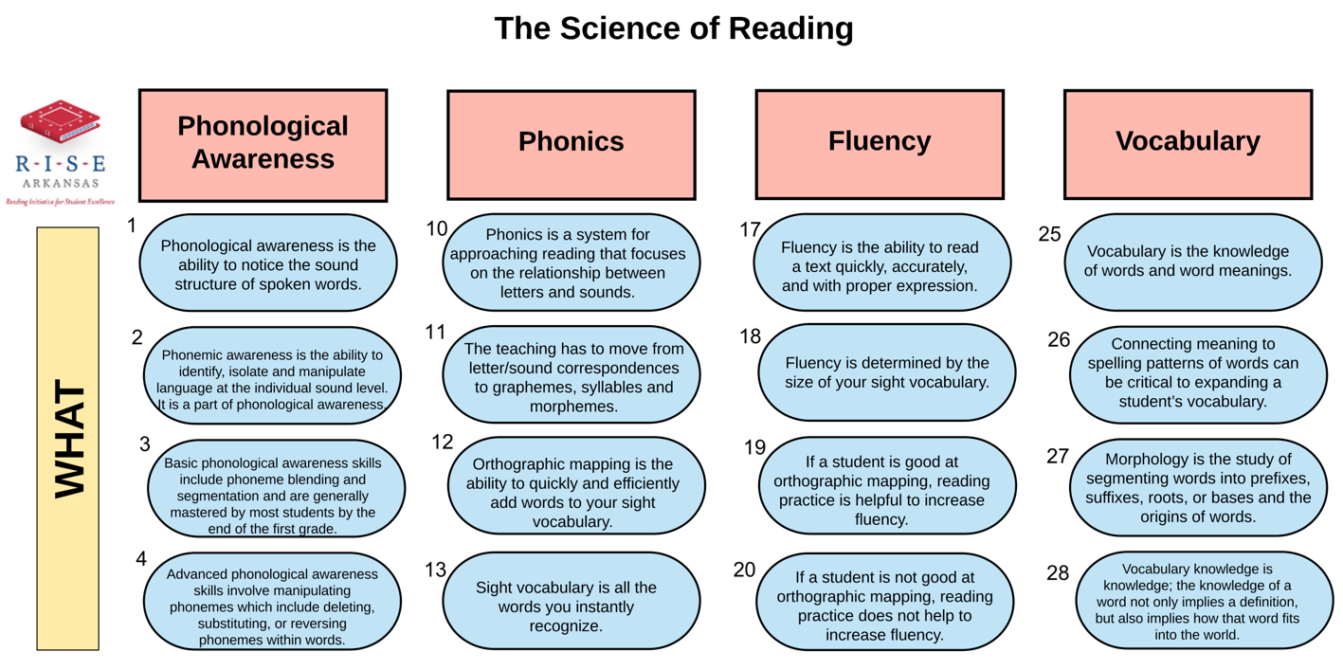
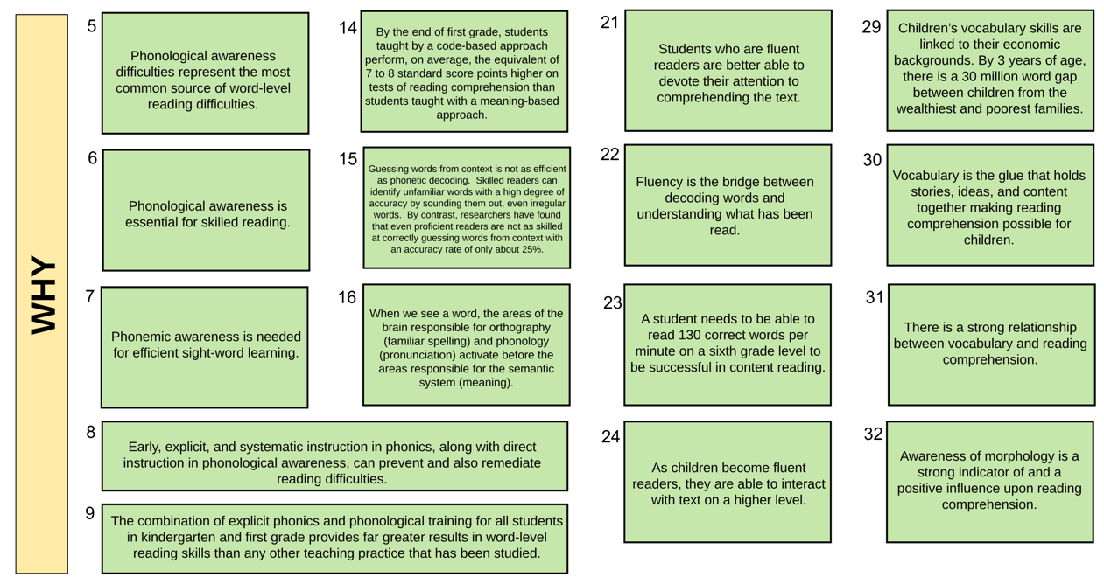
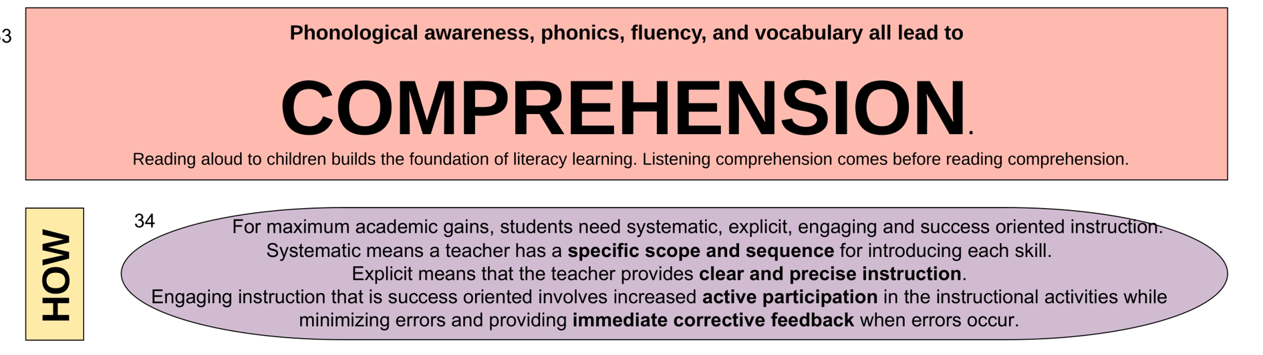

Recommended for Further Reading/References/Resources:
Amplify. Science of Reading: The Podcast @ https://open.spotify.com/show/37fvs1dgedM2DgRHkYWOyv

Liana Loewus (2019). What Teachers Should Know About the Science of Reading (Video and Transcript). EducationWeek.

https://ga.dyslexiaida.org/science-of-reading-resources/
https://pridereadingprogram.com/the-science-of-reading-what-all-teachers-should-know/
https://www.shanahanonliteracy.com/ppt-resources

